Name: ____________________________________

Fill in proofs review

1. **Given:** 

**Prove: **



1. **Given:** 

Prove: 



**3.**

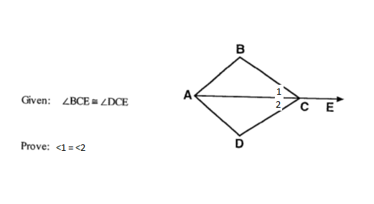

**4.**

